Assignment 14

Swaraj Wattamwar

Jensen huang

150096724157

Google appSheet database: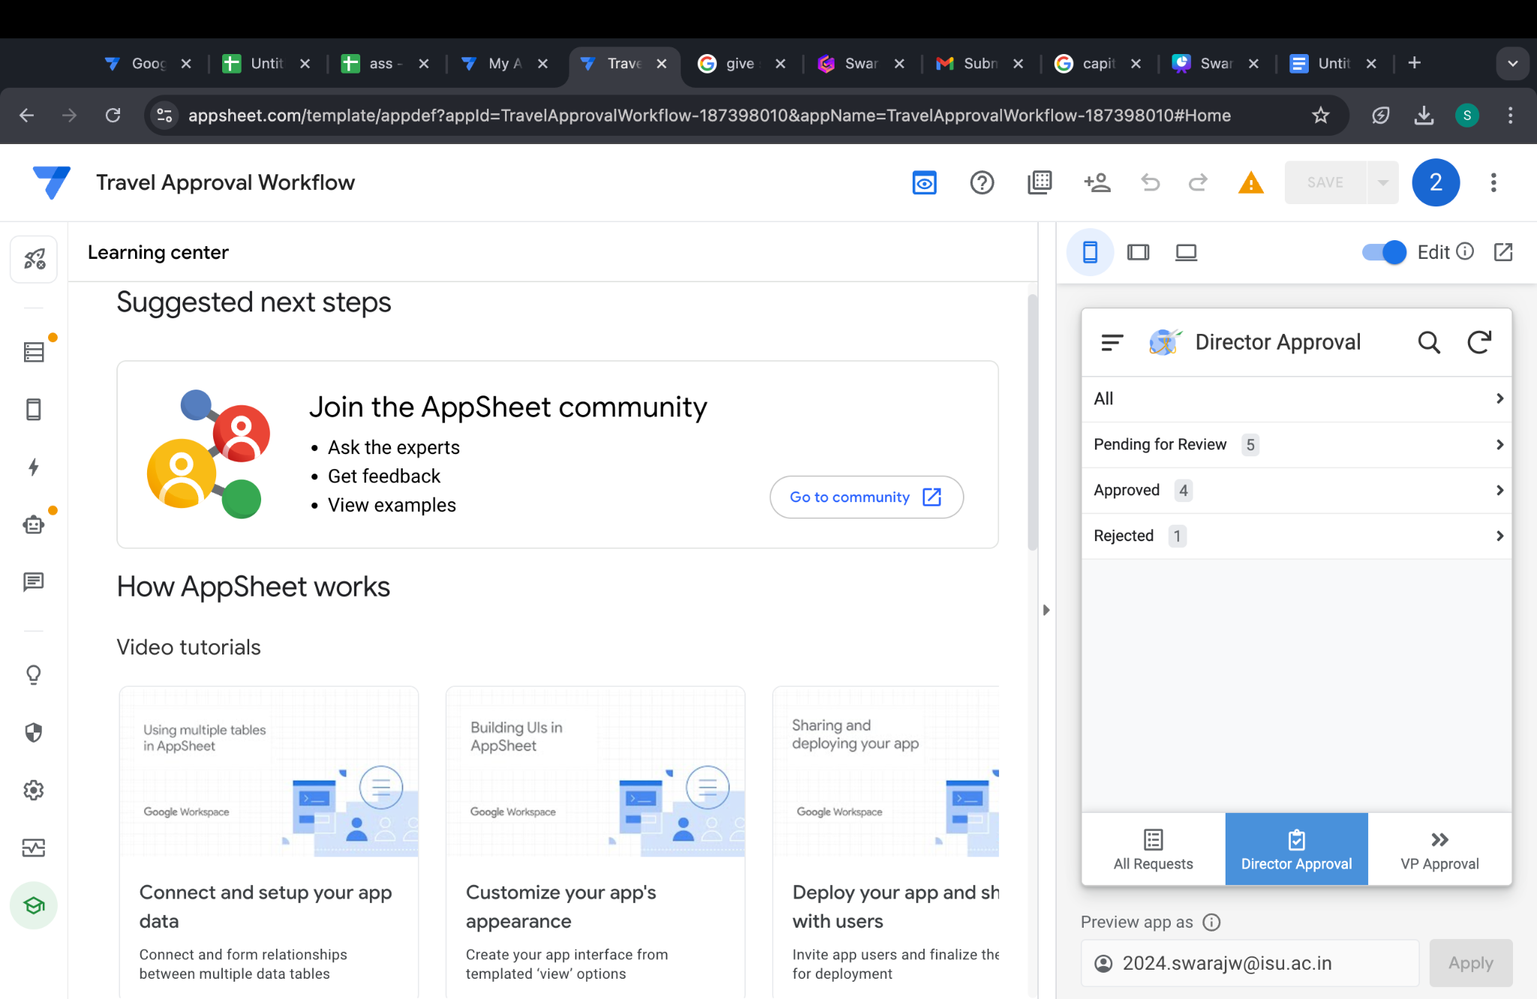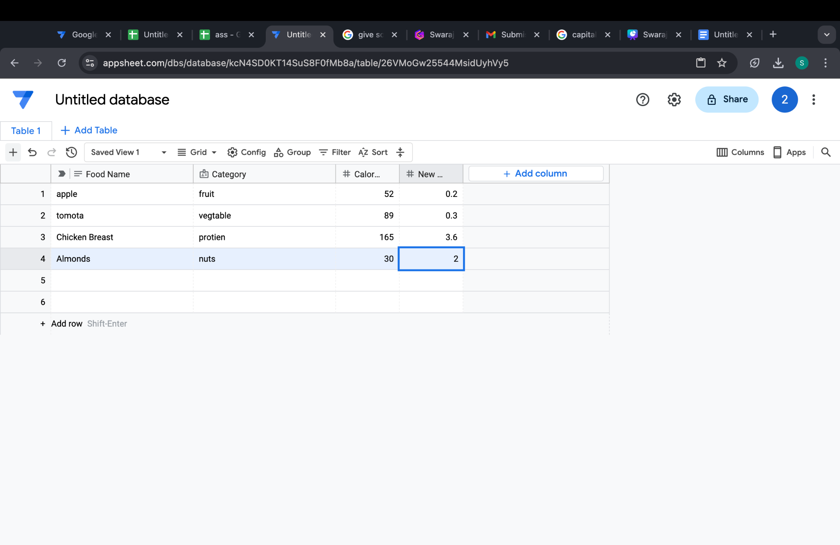

appSheet app: